
5天4晚 巴拉望
5D4N Palawan
GROUND ARRANGEMENT | (T/C: GA-PPC) SEAT IN COACH | UPDATED: 08MAR2019


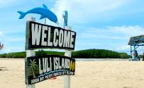
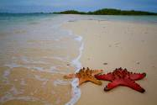

Day 1 – Arrival in Palawan (-) | 抵达巴拉望 （-）
Arrival in Puerto Princesa Airport. Meet and transfers to hotel. Check in at the hotel.

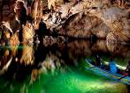
Day 2 – Underground River Tour (B/L) | 地底河流（早/午餐）
After breakfast, proceed to underground river tour. Travel time from the hotel to Sabang boat terminal is approximately 2 hours. Underground river, you will see different rock formation inside the cave and be entertained of their mythological stories. After the tour, walk back to your respective boats then transfer back to the wharf. Proceed to you lunch venue at one of the local restaurants at Sabang beach. Then transfer back to the Hotel.

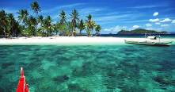
Day 3 – Honda Bay Island Tour (B/L) | 本田湾跳岛游（早/午餐）
After breakfast, tour guide will be waiting at the hotel lobby to assist you to your activity today. Proceed to your respective coach. Transfer to the wharf of Honda Bay, Proceed to your assigned boats. Start of the Island-Hopping Tour. The tour will go to the following islands: Luli Island, Starfish Island and Cowrie Island. (depends to tide and weather condition) Enjoy a picnic lunch in one of the islands. Afterwards, Free time to swim, snorkel or fish feed. Return to the hotel.

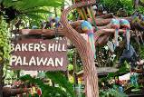
Day 4 – City Tour of Puerto Princesa (B) | 普林塞薩港（早餐）
After breakfast, tour guide will be waiting at the hotel lobby to assist you to your activity today. Proceed to your respective coach. Start of City tour. Places to visit includes: Immaculate Church, Bakers Hill, Mitra Ranch, Puerto Princesa Baywalk, Souvenir Shop, Plaza Cuertel, Binuatan Weaving Center, and Crocodile. Return to the hotel.

Day 5 – Departure| 启程回国 （早餐）
Breakfast at the Hotel. Check Out. Proceed to hotel lobby. Meet our Airport coordinator then transfer to Puerto Princesa Airport (早餐后，送往机场).

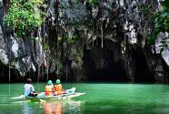
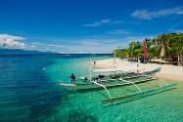
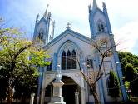

*Sequence of itinerary subject to local arrangement*

Breakfast at the Hotel. Check Out. Proceed to hotel lobby. Meet our Airport coordinator then transfer to Ninoy Aquino International Airport (早餐后，送往机场).

*Sequence of itinerary subject to local arrangement*
HOTEL  (Or similar) |  | Travelling Period: 01 APR 2019 – 30 SEP 2019
 |  | Twin / Triple  Room Share  (per Adult) | Single  Supp. | Ext. Night with Breakfast  (per room per night)
 |  | Twin / Triple  Room Share  (per Adult) | Single  Supp. | Single /  Twin Room | Triple  Room
3* | ACACIA TREE GARDEN HOTEL | 1080 | 515 | 305 | 390
3* | Acacia Tree Garden Hotel Block out date: 01 – 30 APR 2019
3* | HOTEL CENTRO | 1160 | 590 | 350 | 485
3* | CANVAS BOUTIQUE HOTEL | 1400 | 825 | 485 | 580
3* | LEGEND PALAWAN | 1230 | 670 | 395 | 570
4* | BEST WESTERN PLUS THE IVYWALL HOTEL | 1525 | 945 | 555 | 765
4.5* | PRINCESA GARDEN ISLAND RESORT & SPA | 1820 | 1215 | 720 | 950

***Block out date:14 – 25 APR 2019***
Remarks:
- Min. 2 adults per booking (GV2).
- Tour packages are only applied for Malaysian passport holder.
- Prices are quoted per person in Ringgit Malaysia (MYR) & subject to change without prior notice.
- Recommended tipping and gratuities: USD 3/pax/day. (direct pay to local guide)
- Roundtrip airport transfer assisted with our airport coordinator (without tour guide).
- English speaking guide provided only.
- Agent collection fees: (ACF) RM 30/pax
- Deposit of RM 300/pax upon booking confirmation with is non-refundable.
- Child fare: 100% of adult fare (Twin Share), 100% of adult fare (With Extra Bed), 85% of adult fare (Child without bed)
- Hotel rooms are subject to availability. If selected hotel unavailable, others similar accommodation will be provided with different price apply (if any).

