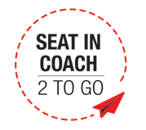
3天2晚 巴拉望
3D2N Palawan
GROUND ARRANGEMENT | (T/C: GA-PPA) SEAT IN COACH | UPDATED: 05SEP2018
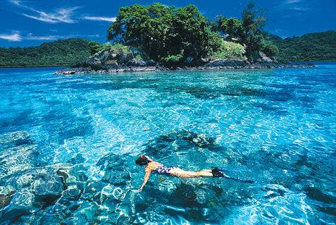
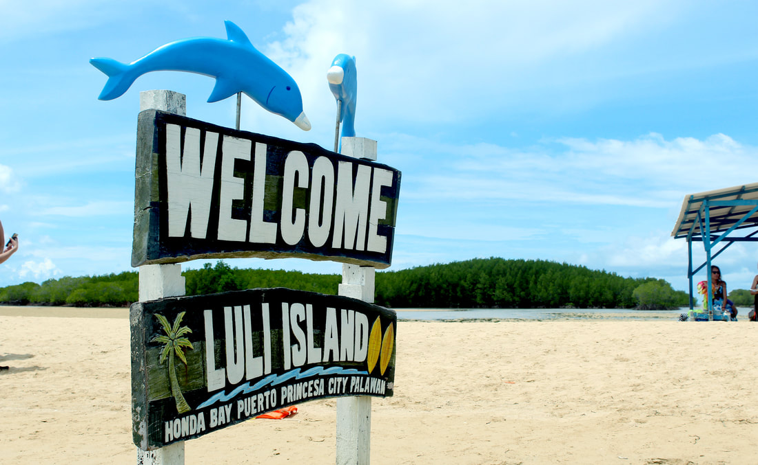
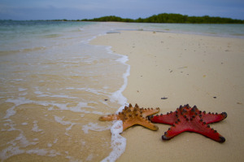

Day 1 – Arrival in Palawan (-) | 抵达巴拉望 （-）
Arrival in Puerto Princesa Airport. Meet and transfers to hotel. Check in at the hotel.

Day 2 – Honda Bay Island Tour (B/L) | 本田湾跳岛游（早/午餐）
After breakfast, tour guide will be waiting at the hotel lobby to assist you to your activity today. Proceed to your respective coach. Transfer to the wharf of Honda Bay, Proceed to your assigned boats. Start of the Island-Hopping Tour. The tour will go to the following islands: Luli Island, Starfish Island and Cowrie Island. (depends to tide and weather condition) Enjoy a picnic lunch in one of the islands. Afterwards, Free time to swim, snorkel or fish feed. Return to the hotel.

Day 3 – Departure| 启程回国 （早餐）
Breakfast at the Hotel. Check Out. Proceed to hotel lobby. Meet our Airport coordinator then transfer to Puerto Princesa Airport (早餐后，送往机场).

*Sequence of itinerary subject to local arrangement*
Breakfast at the Hotel. Check Out. Proceed to hotel lobby. Meet our Airport coordinator then transfer to Ninoy Aquino International Airport (早餐后，送往机场).

*Sequence of itinerary subject to local arrangement*
HOTEL  (Or similar) |  | Travelling Period: 01 Sep 2018 – 31 Mar 2019
 |  | Twin / Triple  Room Share  (per Adult) | Single  Supp. | Ext. Night with Breakfast  (per room per night)
 |  | Twin / Triple  Room Share  (per Adult) | Single  Supp. | Single /  Twin Room | Triple  Room
3* | ONE MANALO PLACE | 485 | 265 | 315 | 400
3* | HOTEL CENTRO | 495 | 275 | 325 | 465
3* | CANVAS BOUTIQUE HOTEL | 570 | 350 | 415 | 530
3* | LEGEND PALAWAN | 590 | 365 | 435 | 610
4* | BEST WESTERN PLUS THE IVYWALL HOTEL | 645 | 420 | 500 | 705
4.5* | PRINCESA GARDEN ISLAND RESORT & SPA | 735 | 505 | 605 | 815

***Block Out Date: 15 DEC 2018 – 08 JAN 2019***
***Chinese New Year Block Out Date: 01 FEB 2019 – 10 FEB 2019***

Remarks:
- Min. 2 adults per booking (GV2).
- Tour packages are only applied for Malaysian passport holder.
- Prices are quoted per person in Ringgit Malaysia (MYR) & subject to change without prior notice.
- Recommended tipping and gratuities: USD 3/pax/day. (direct pay to local guide)
- Roundtrip airport transfer assisted with our airport coordinator (without tour guide).
- English speaking guide provided only.
- Agent collection fees: (ACF) RM 30/pax
- Deposit of RM 300/pax upon booking confirmation with is non-refundable.
- Child fare: 100% of adult fare (Twin Share), 100% of adult fare (With Extra Bed), 85% of adult fare (Child without bed)
- Hotel rooms are subject to availability. If selected hotel unavailable, others similar accommodation will be provided with different price apply (if any).

