3Days 2Nights MULTI ATTRACTIONS PACKAGE
www.rwsentosa.com
Resort World Sentosa Package | UPDATED: 27MAY2019

Booking Period : 01 June 2019 – 29 March 2020
Staying Period : 01 June 2019 – 31 March 2020

3D2N MULTI ATTRACTIONS PACKAGE
(U.S.S + Adventure Cove Waterpark)
- 2 Nights Stay at the following hotels:  - Hard Rock Hotel (Deluxe)  - Hotel Michael (Deluxe)  - Festive Hotel (Deluxe Family) – 2 pax  - Equarius Hotel (Deluxe)  - Genting Jurong (Superior)  Inclusions:  - Hotel Breakfast for 2 Adults  - One Day Ticket to Universal Studios Singapore for 2 Adults  - One Day Ticket to Adventure Cove Waterpark for 2 Adults  - One Day Ticket to MEMA & Typhoon Theatre for 2 Adults | Rate Per Package (MYR)
 | Hotel | WD/LOW | WE/PEAK
 | Hotel Michael (Deluxe) | 2660 | 3280
 | Hard Rock Hotel (Deluxe)  / Equarius Hotel (Deluxe) | 2815 | 3375
 | Festive Hotel (Deluxe Family) – 2 pax | 2940 | 3560
 | Genting Jurong (Superior) | 1935 | 2245
Additional Pax for Hard Rock Hotel / Hotel Michael / Festive Hotel / Equarius Hotel (MYR)
Additional 1 Pax Amenities  Hotel Breakfast for 1  One Day Ticket to Universal Studios Singapore for 1  One Day Ticket to Adventure Cove Waterpark for 1  One Day Ticket to MEMA & Typhoon Theatre for 1 | Adult  (HM/HRH/FH/EH) | 1075
 | Child  (HM/HRH/FH/EH) | 935
 | Child without Bed  (HM/HRH/FH/EH) | 440

Blackout Dates:
RWS Hotels: 06 – 09 JUN 2019 / 09 – 11 AUG 2019 / 28 – 31 DEC 2019 / 24 – 27 JAN 2020; GHJ: N/A

Seasonality:
WD = Sundays to Thursday ; WE = Fridays to Saturdays
LOW = Sundays to Fridays ; PEAK = Saturdays & date fall on PEAK base on Demand Calendar 2019/2020
Genting Hotel Jurong: WE/PEAK: 05 – 08 Jun 2019 / 20 – 21 Sep 2019 / 28 – 31 Dec 2019 / 24 – 27 Jan 2020

Remark:
- Strictly applicable for Malaysian Passport holder only.
- Above hotel is subject to room availability; kindly check with us.
- Non-refundable, no amendment (including name changes) and full payment upon confirmation.
- Above hotel rates is subject to change without prior notice.
- Tickets & Meal Vouchers to be valid during stay period only.
- We reserve the right to change, add, delete and/or amend the above package without prior notice.

3Days 2Nights MULTI ATTRACTIONS PACKAGE
www.rwsentosa.com
Resort World Sentosa Package | UPDATED: 27MAY2019

Booking Period : 01 June 2019 – 29 March 2020
Staying Period : 01 June 2019 – 31 March 2020

3D2N MULTI ATTRACTIONS PACKAGE
(U.S.S + S.E.A. Aquarium)
- 2 Nights Stay at the following hotels:  - Hard Rock Hotel (Deluxe)  - Hotel Michael (Deluxe)  - Festive Hotel (Deluxe Family) – 2 pax  - Equarius Hotel (Deluxe)  - Genting Jurong (Superior)  Inclusions:  - Hotel Breakfast for 2 Adults  - One Day Ticket to Universal Studios Singapore for 2 Adults  - One Day Ticket to S.E.A. Aquarium for 2 Adults  - One Day Ticket to MEMA & Typhoon Theatre for 2 Adults | Rate Per Package (MYR)
 | Hotel | WD/LOW | WE/PEAK
 | Hotel Michael (Deluxe) | 2660 | 3280
 | Hard Rock Hotel (Deluxe)  / Equarius Hotel (Deluxe) | 2815 | 3375
 | Festive Hotel (Deluxe Family) – 2 pax | 2940 | 3560
 | Genting Jurong (Superior) | 1935 | 2245
Additional Pax for Hard Rock Hotel / Hotel Michael / Festive Hotel / Equarius Hotel (MYR)
Additional 1 Pax Amenities  Hotel Breakfast for 1  One Day Ticket to Universal Studios Singapore for 1  One Day Ticket to S.E.A. Aquarium for 1  One Day Ticket to MEMA & Typhoon Theatre for 1 | Adult  (HM/HRH/FH/EH) | 1080
 | Child  (HM/HRH/FH/EH) | 925
 | Child without Bed  (HM/HRH/FH/EH) | 430

Blackout Dates:
RWS Hotels: 06 – 09 JUN 2019 / 09 – 11 AUG 2019 / 28 – 31 DEC 2019 / 24 – 27 JAN 2020; GHJ: N/A

Seasonality:
WD = Sundays to Thursday ; WE = Fridays to Saturdays
LOW = Sundays to Fridays ; PEAK = Saturdays & date fall on PEAK base on Demand Calendar 2019/2020
Genting Hotel Jurong: WE/PEAK: 05 – 08 Jun 2019 / 20 – 21 Sep 2019 / 28 – 31 Dec 2019 / 24 – 27 Jan 2020

Remark:
- Strictly applicable for Malaysian Passport holder only.
- Above hotel is subject to room availability; kindly check with us.
- Non-refundable, no amendment (including name changes) and full payment upon confirmation.
- Above hotel rates is subject to change without prior notice.
- Tickets & Meal Vouchers to be valid during stay period only.
- We reserve the right to change, add, delete and/or amend the above package without prior notice.

RWS Restricted

RESORTS WORLD AT SENTOSA
DEMAND CALENDAR YEAR 2019 / 2020 - UPDATED 27MAY2019

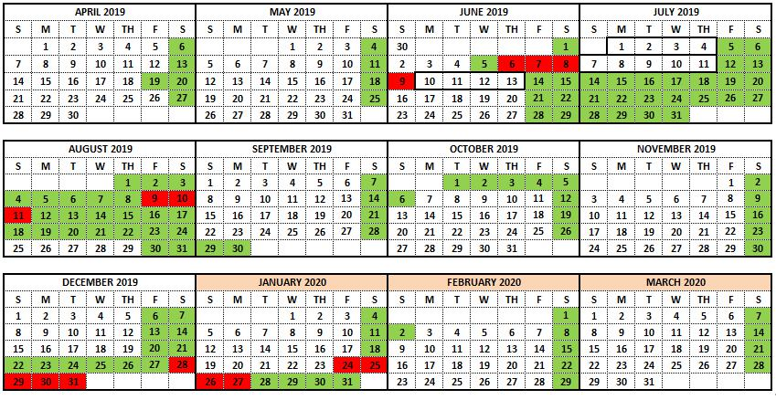

Low Season Peak Season Super Peak Season

RWS Restricted

GENTING HOTEL JURONG
DEMAND CALENDAR YEAR 2019 / 2020 - UPDATED 27MAY2019
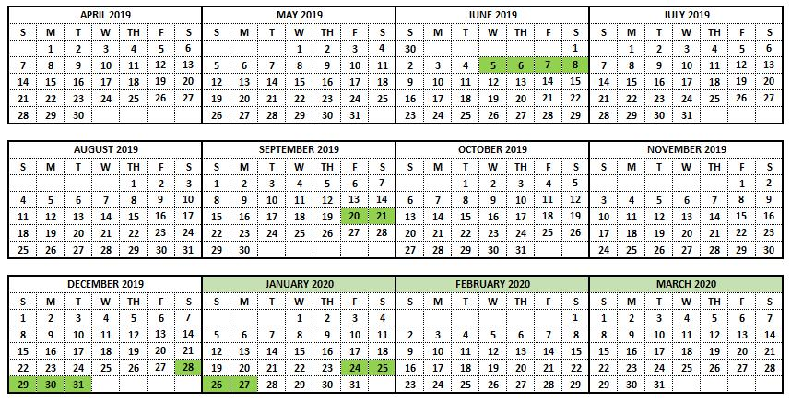

Low Season Peak Season

