Resort World Sentosa Hotel Rate www.rwsentosa.com
Resort World Sentosa Hotel Rates | UPDATED: 24JUN2019

Hotel Room Rates (01 July 2019 – 31 March 2020)

HOTEL | Hotel Room Rate without ABF  (Per Room Per Night) MYR |  | Extra Bed | American Breakfast  (Buffet | Per Pax) MYR
HOTEL | LOW | PEAK | Extra Bed | Adult | Child
Hotel Michael
Deluxe Room | 895 | 1205 | 320 | 70 | 40
Festive Hotel
Deluxe Room | 880 | 1190 | 320 | 70 | 40
Deluxe Family King Room | 1035 | 1345 | 320 | 70 | 40
Hard Rock Hotel
Deluxe Room | 955 | 1250 | 320 | 70 | 40
Equarius Hotel
Deluxe Room | 970 | 1250 | 320 | 70 | 40
Genting Hotel Jurong
Superior Room | 570 | 725 | N/A | 50 | 30
Deluxe Room | 710 | 925 | 275 | 50 | 30

Remarks:
- Above hotel rates is excludes breakfast.
- Above hotel rates is subject to change without prior notice.
- Above hotel is subject to room availability.
- Upon booking confirm cancellation & amendment is NOT ALLOWED.

SEASONALITY CHART
RESORTS WORLD AT SENTOSA YEAR 2019 / 20 – UPDATED 27 MAY 2019
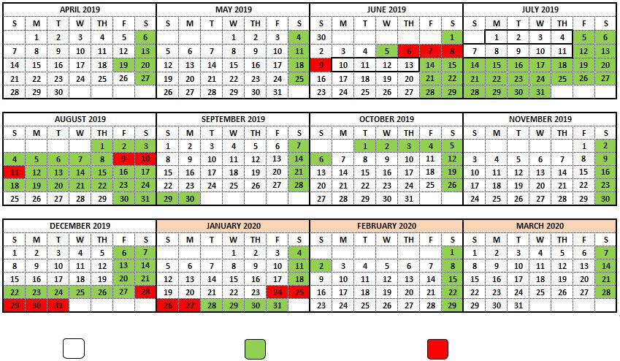

Low Season Peak Season Super Peak Season

*Subject to changes without prior notice.

Y2019/2020 Seasonality Chart for GHJ *:

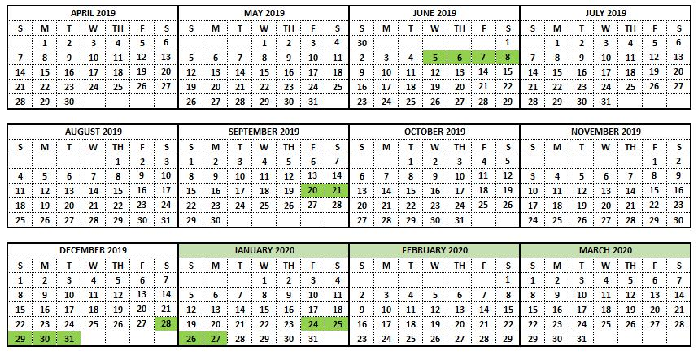

Low Season Peak Season

*Subject to changes without prior notice.

